**4.2.** The N-Curve plots are made using python with the script ***Plot_4.2.py*** attached to the submission.

For 4-lanes, the jam density K=150*4=600 veh/km. The “virtual arrival” curve is made by shifting A(t) by (xo-xA)/u=(2-0)/100=0.02 in time-axis.

The “virtual departure” is created by shifting D(t) by (xD-x0)/ω=(4-2)/20=0.1 along time axis and by K(xD-x0)=600(4-2)=1200 along the N-axis.

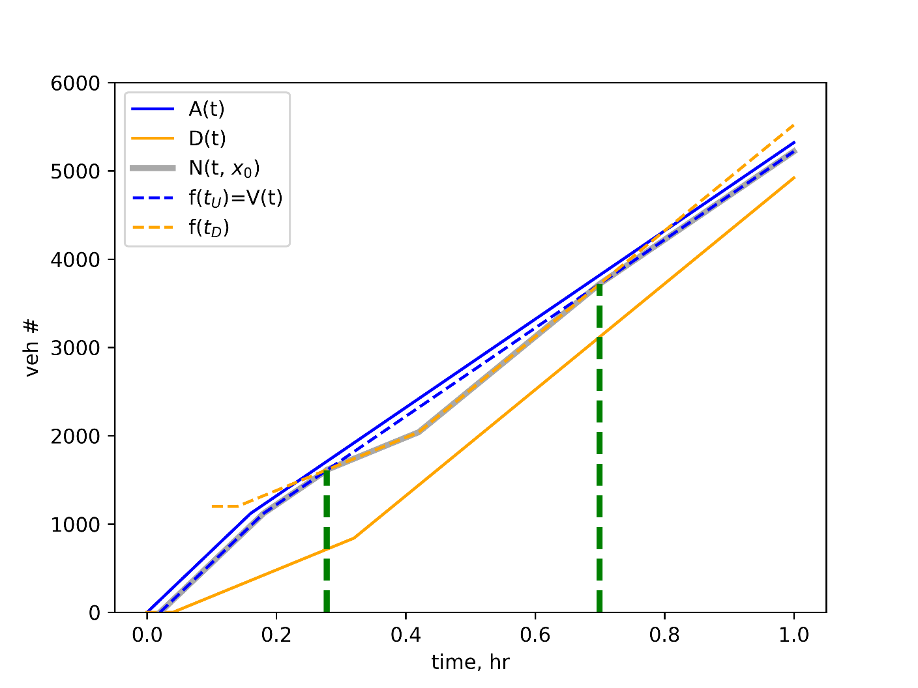

1. The shaded area represents N-curve at x=2 km.
2. The green lines denote two intersections at t=0.2776 hr and t=0.6995 hr. in the first instance the queue starts growing and then in the second instance, the queue starts receding.